Integrations and GUI Enhancement using PeopleSoft Enterprise Portal
Authors: Shashi Nath Kumar
Rama Krishna Subrahmanya
Date May 2010

Table of Contents
Abstract 3
Business case 4
Solution 5
Integration 5
Single Sign On 6
User profile Synchronization: 7
Security 7
Worklist Consolidation 8
Third Party Integration 9
User Experience Enhancements 10
Overall Look and Feel - Branding 10
iFrame based Pagelets 11
Quick Links 12
Ticker News 13
Mouse-hover Help Tooltips 13
Segregated LH Menu – Multiple Portals 14
Login screen Changes 15
Different look and feel for various tabs 16
Conclusion 18
References 18

Abstract/ Executive Summary:

This document covers an overview of enhancements done in PeopleSoft enterprise portal to have improved end user experience by providing state of art look and feel and single gateway for all PeopleSoft applications through integration methodologies available in PeopleSoft. It is solely intended to help you asses the business benefits of implementing and configuring/customizing PeopleSoft Portal and plan your IT Project.
PeopleSoft Enterprise Portal provides a selection of out-of-the-box features that enable you to quickly implement the portal. With Pure Internet Architecture of PeopleSoft, You can deploy enterprise-wide access to internet-based applications, unstructured content, a searchable resource repository, and collaborative services through an internet browser.
All features of PeopleTools can be leveraged for integration with different systems so have a single gate of entry for the enterprise data. With minimal customization and front end driven configuration, end user experience can be exponentially increased.

Business Case:

Most organizations implement ERP for business reasons and look for the solution of their business problems by reducing total cost of ownership of the Software.
Most of the ERP are designed for back office operations and hence lacks the wow effect for end users. With the advent of Web 2.0, its interface and interactivity, end users expectations are increasing day by day from any web content. At the same time, as ERP systems are intended to solve business problems, customizations are generally avoided for complexity and ease of maintenance and future upgrades. The penultimate victim of this taboo is GUI, which leads to a mundane delivered look and feel for end users. The severity of the problem increases when the ERP system is having huge number of end users like HRMS and financials self services.
When multiple ERP systems are implemented to address business needs, end users get over burdened by multiple sites login credentials. Aggravated by unsynchronized GUI of different products from different vendors, it is end user, whose expectations are compromised.

In current business environment, need is of an integrated users interface which can display information from multiple systems to the end users with contemporary GUI.
PeopleSoft Enterprise Portal provides Branding (GUI configuration), Single Sign On (Single gate way for all PS and Non PS environments), Site management (rapid deployment of sites) With Pure Internet Architecture of PeopleSoft, with which, You can deploy enterprise-wide access to internet-based applications, unstructured content, a searchable resource repository, and collaborative services through an internet browser with Web 2.0 features and single gateway for all end user facing contents.

Solution:

The solutions provided were focused on showing end user facing contents to the users through single gateway of entry with contemporary Web 2.0 GUI. PeopleSoft Enterprise Portal is implemented having SSO with HCM and Financials and Common data is synchronized across database with integration technologies depending upon the nature of the requirements.

Integration:
PeopleSoft Users were accessing all instances separately using basic PIA/Portal pack deployed for each instance. All database had common user IDs and password stored in LDAP, but login URLs were different with discrepancy in look and feel. New Portal has full folder navigation enabled with all modules in PeopleSoft accessed through it.

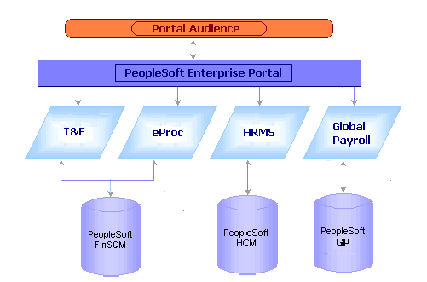

Major Solutions provided are:
- Single Sign On
- User Profile Synchronization
- Security – Roles, PL, Content References
- Worklist Consolidation
- Third Party Integration

Single Sign On:
Single sign on refers to the ability of users to navigate freely within a system of multiple applications after only being authenticated once. PeopleSoft-only SSO was enabled to trust contents from HRMS, GP and financials. When the system authenticates a user, it distributes the PS_TOKEN cookie to the browser. The PS_TOKEN cookie holds user authentication information in the browser that a PeopleSoft system uses to verify user access. Having the token in the browser memory allows the user to navigate freely within the system without having to provide user credentials repeatedly
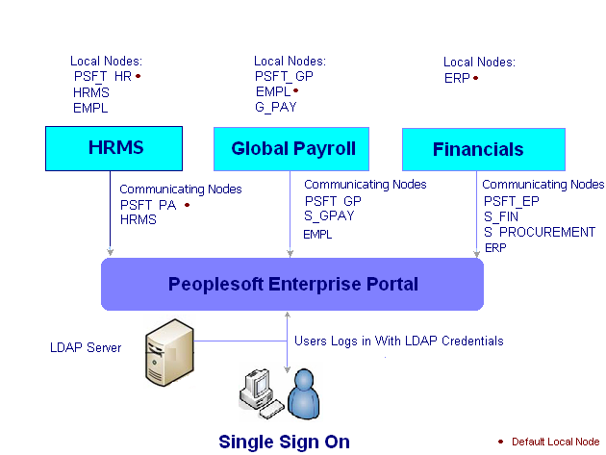
User profile Synchronization:
User profiles are created in HRMS instance when a person is hired. The user profile information flows to PeopleSoft Enterprise Portal real time through Data Base triggers and Data Base Links and to Financials as Batch Process. In Enterprise Portal, Portal generic roles and Meeting Room and Desk Booking System roles are assigned automatically to all users based on defined business rules. Financials Specific roles are assigned to users based on business process in Financials and that is published to Enterprise Portal through Integration Broker as batch process. The Enterprise Portal database has Portal generic roles along with HRMS specific roles and Financials specific roles assigned to user profiles.
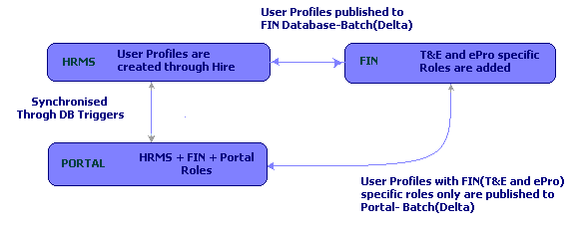

Security – Roles, PL, Content References:
- Any New Roles/PL created in HRMS will flow to Portal by Triggers
- Any New Roles/PL created in FI will be manually Copied to portal
- All Roles and PL across database are Unique to Each other
- Total Number of Roles available to any user in Portal is HRMS Roles + FIN Roles
- Any New Component created in HRMS/FIN will be manually registered in Portal
- HRMS/FIN Component Content Reference will have respective PL tagged to it.
Worklist Consolidation:
Worklist items are generated in content provider database when ever a business process related to workflow item is triggered. The transaction is handled fully in content provider database but the Worklist keys are stored in portal database pointing to those items in content providers. Whenever a Worklist is updated in content provider database, an XML message is published using Integration Broker to Portal database to update its status. In this way, user can see all his/her PeopleSoft Worklist consolidated at one place in Pagelet deployed on Homepage of PS Portal. With the help of Keys, the business process name of the Worklist list items are made as clickable links pointing those items in content provider database. User can click on these links to open Worklist component and action on the respective item from PS Portal.

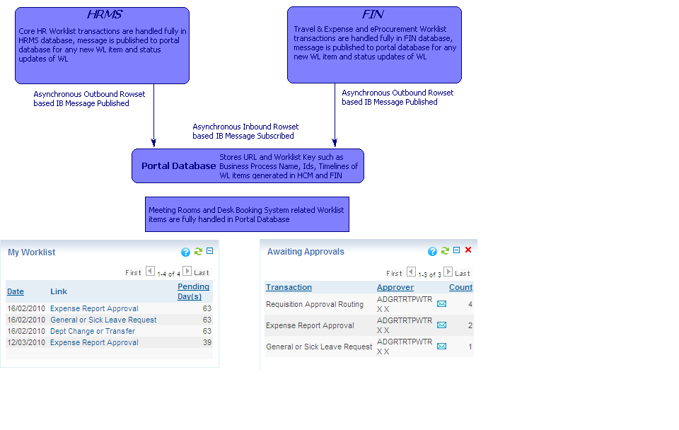

Third Party Integration:
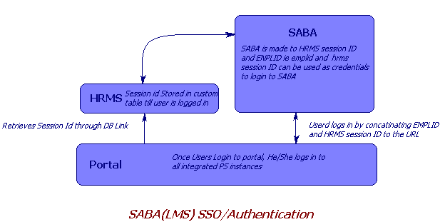

PeopleSoft Enterprise Portal is integrated with SABA, the Leaning Management System. Indirectly HRMS is integrated with SABA as a trusted application where a user can navigate to SABA directly with PeopleSoft session ID and PS Employee ID. To access it from portal, session ID is fetched from HRMS with DB Link and his EMPL id and PS session ID is concatenated with the base URL to navigate directly to respective pages without re authentication.

User Experience Enhancements
With minimal customization and front end driven configuration, end user experience can be exponentially increased. Using HTML templates, PeopleSoft/Inline CSS and Branding configuration the look and feel have been changed altogether. JQuery library have been used to display mouse hover tooltip as help content. Multiple Portal regisry allows creation of segregated LH Menu.
Major Solutions provided are:
- Overall Look and Feel - Branding
- iFrame based Pagelets
- Quick Links
- Ticker News
- Mouse-hover Help Tooltips
- Segregated LH Menu – Multiple Portals
- Login screen Changes
- Different look and feel for various tabs
Overall Look and Feel – Branding
PeopleSoft Enterprise Portal enables you to apply various branding themes to the portal and portal sites to present multiple visual designs and deliver appropriate links for specific user audiences.
Other features of Enterprise Portal Branding enable you to:
- Create your own layouts and incorporate them into the administrative pages.
- Store and maintain multiple themes and their component parts.
- Allow non-technical users to assemble themes and configure images, links, text, and styles.
- Configure images and style classes for menus.
- Leverage predefined HTML layouts for theme parts, like headers and footers.
- Maintain precedence role lists for applying themes.
- Move themes from development to production.
Because branding themes can be applied based on portal registry, site, or user role, using the Enterprise Portal Branding can enable you to meet your portal needs by deploying a single enterprise portal database. This provides the benefit of sharing a common IT infrastructure, as well as a large quantity of unstructured content.
iFrame based Pagelets
- iFrame – Processing/Transaction can take place inside Pagelets
- Snippet of key information- No navigation
- Built on PeopleTools – Advantage Component Buffer
- Look and feel – CSS/HTML
- Mouse-hover Help Tooltip
- Security- Role/Pl Driven
- Content Reference based on iScripts

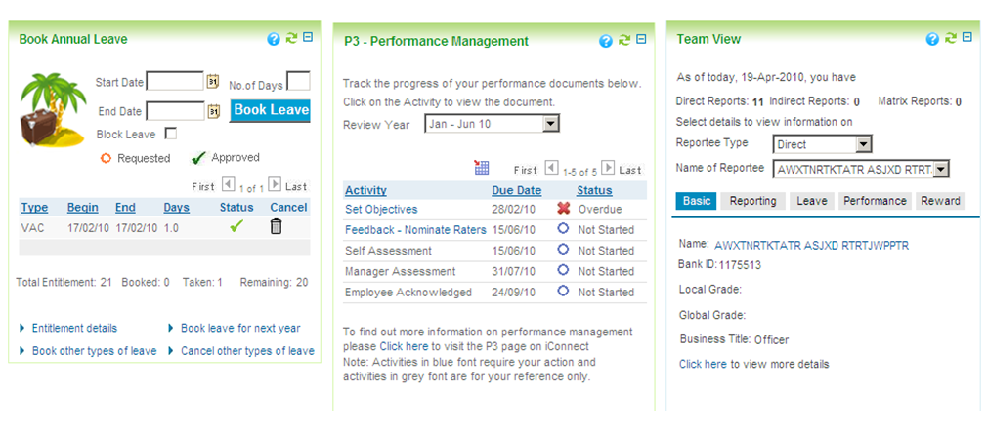

Quick Links Features:
- Quickly Navigate to desired Page
- Fully configurable – PS and non PS both
- External URLs Opens in New Window
- Role Based Links
- Allows User level Personalization- No unwanted links
- iScript based
- Security- Role Driven

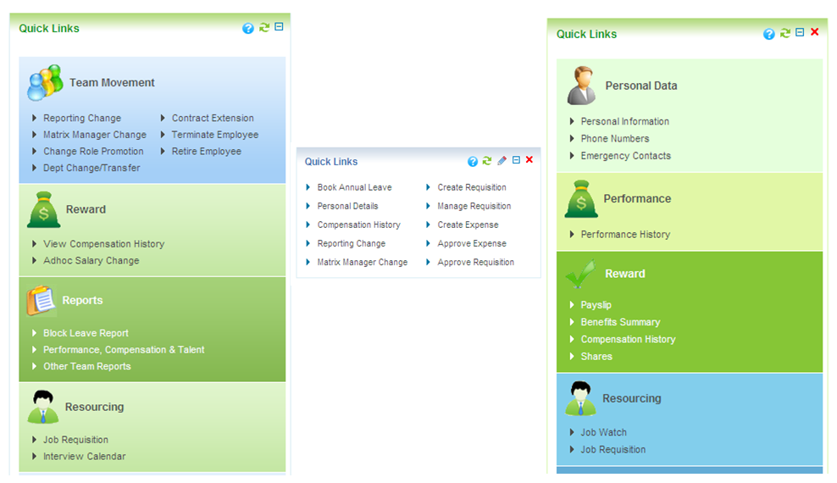

Ticker News Board Features:
- News updates can be Posted very easily
- Fully configurable
- Built On PeopleTools with Aid of JavaScript
- iScript based
- Security- Role/PL Driven

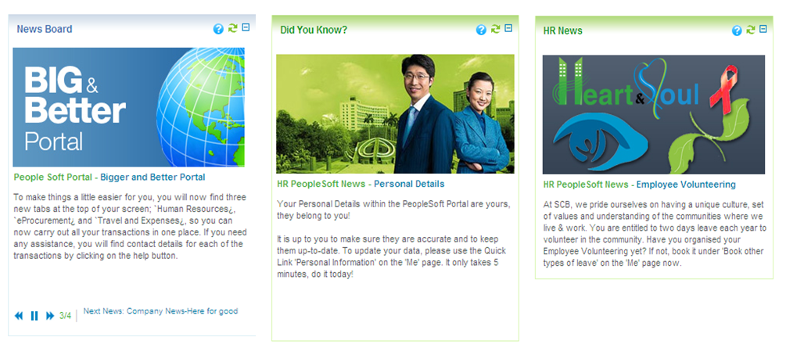

Mouse Hover Tooltip Features:
- Help Tooltip Text
- Text Stored in HTML Object:- Easy to change and Maintain
- JavaScript/CSS driven - Jquery and CSS files stored on web servers
- Can be associated with any element over the Page
- User Satisfaction
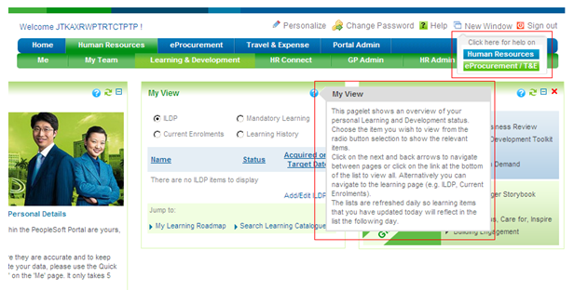
Segregated LH Menu
Separate LH Menu was required for separate module. This was achieved by creating multiple portal registries.

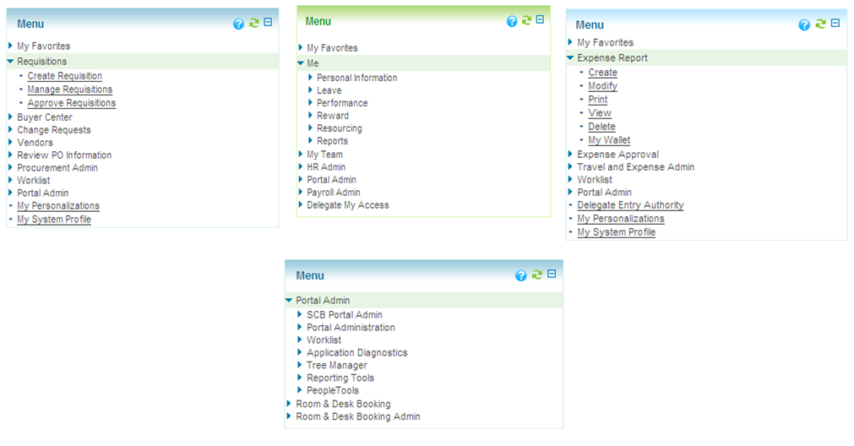
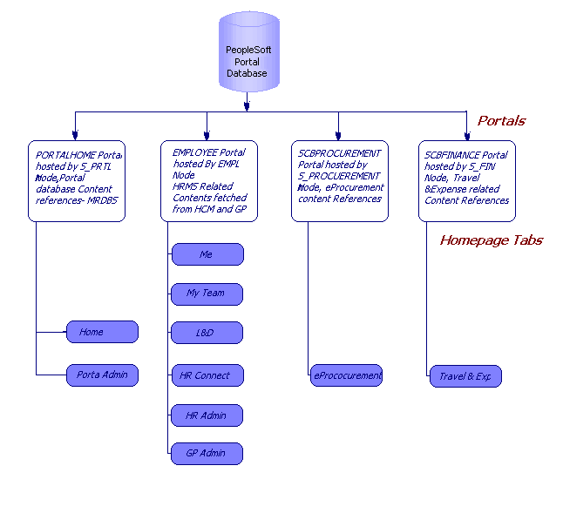
Login Screen Changes:
The First impression is the last impression-
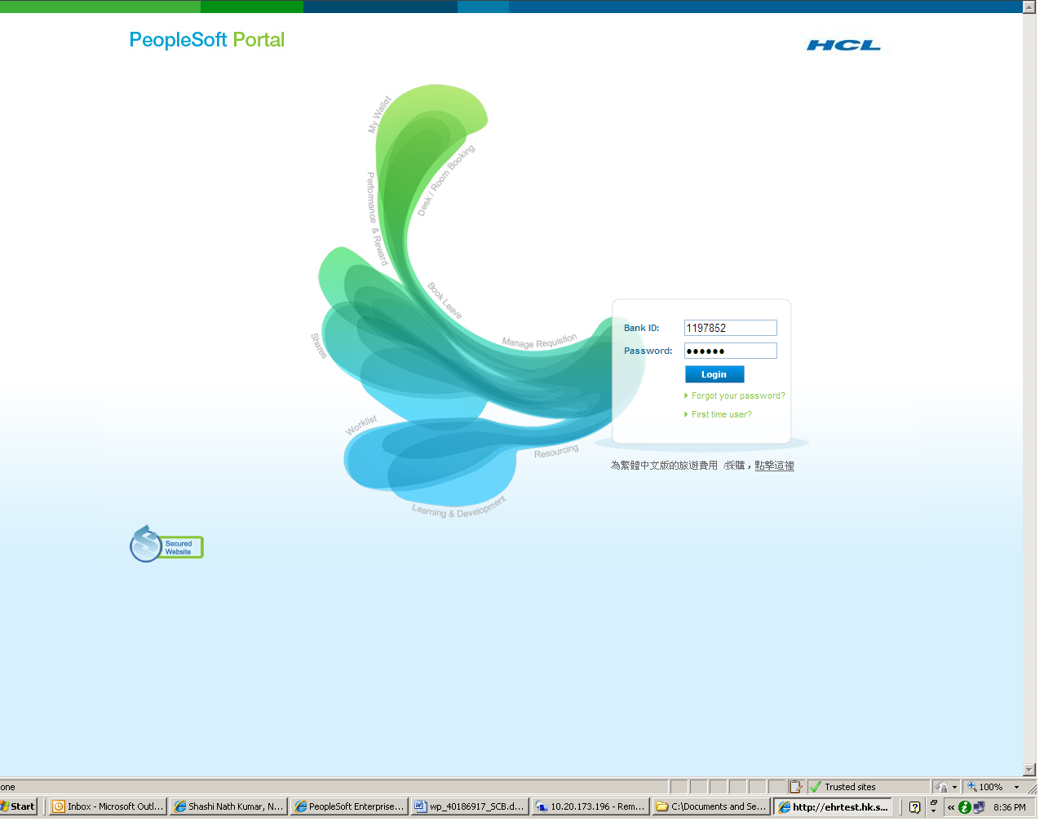
Different Look and feel for various tabs:
With the help of PIA configuration, the different look and feel had been achieved for different content provider tabs. All HRMS related Tabs were looking similar but different from Financials Tabs.
What follows is what we could achieve:
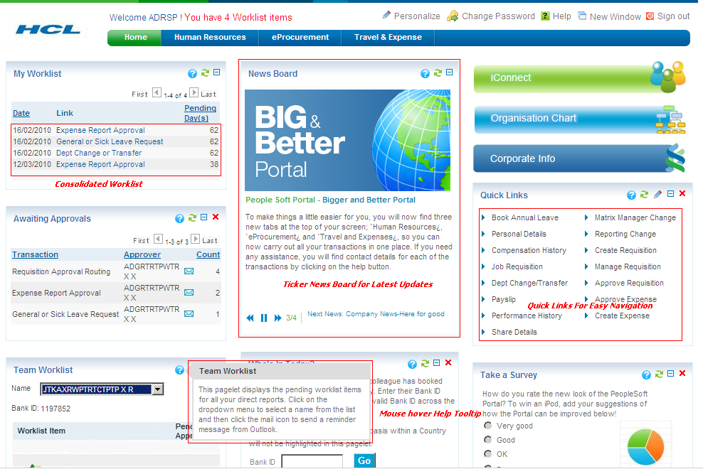
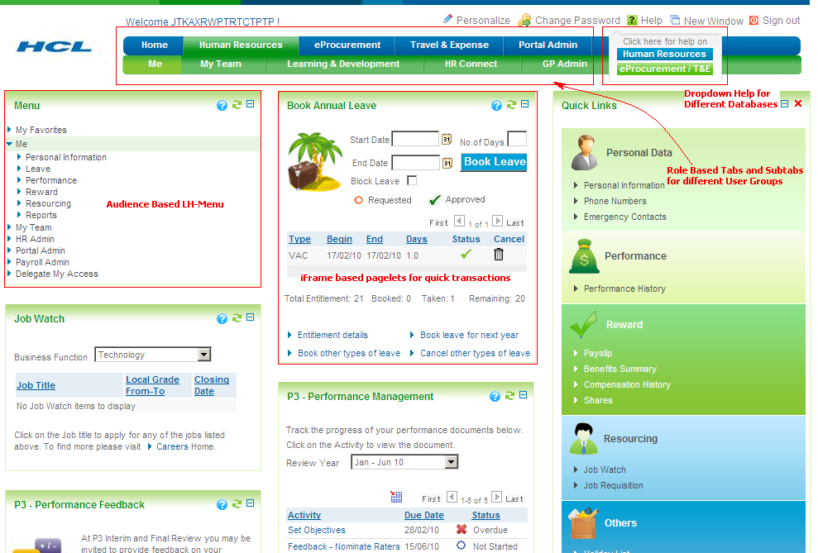

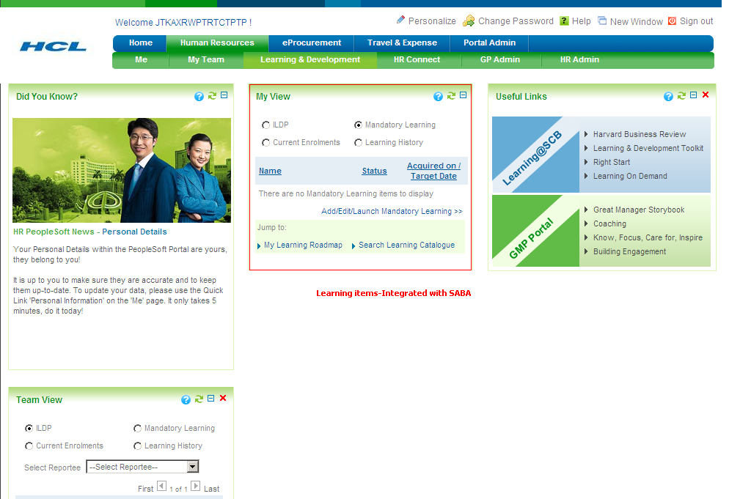
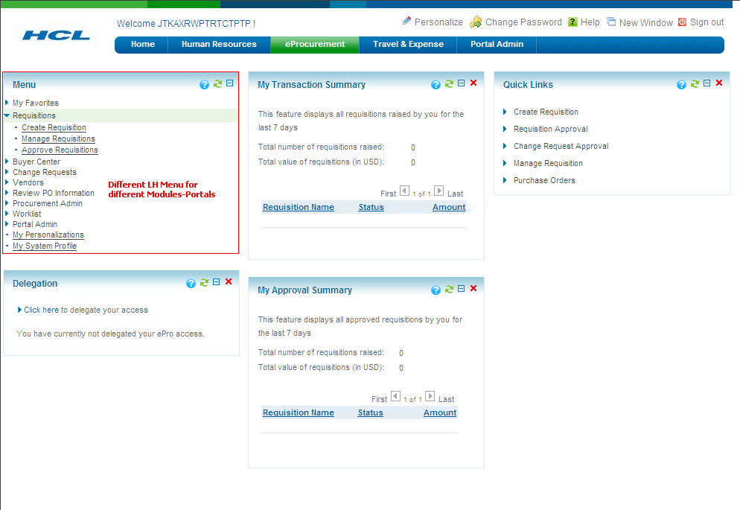

Conclusion:

The solutions implemented were business problem oriented rather then technical problem oriented. Hence the technical nature of solutions was spread over a wide range for both UI enhancement and integration. As a result, there are multiple technical approaches available for some business problems. The Nature of the requirement was generic, what users wanted was single point of entry for enterprise data and a more soothing user interface. Integration and Branding features of Enterprise Portal combined with some customization with the aid of PeopleTools led to State of art look and feel. The approach can be used for any PeopleSoft instance and PS to PS integration irrespective of the nature of the organization and industry in which they have operations in.

References:

Peoplebooks
Experience of past projects

